**Test Case** **0032**

**System:** VirtuCardsClient & VirtucardsHost

**Description:** Tests that songs can be played with the playlist

**Severity:** 3

**Instructions**

**Test 1**

1. Start VirtuCardClient application
2. Click the button labeled “Sign In”
3. Enter “virtucards01@gmail.com” into the text input labeled “Enter email…”
4. Enter “Testing1” into the text input labeled “Enter password…”
5. Press the button labeled “Login”
6. A window should appear saying “Login Success”
7. Press the OK button that appears on that window
8. Start VirtuCardHost application
9. Repeat steps 2-7 but on the VirtuCardHost application
10. The checkbox “Allow Host to Join” should be checked on the host
11. Select the game “TestGame” from the dropdown
12. Press the Create Game button
13. In the VirtuCardClient application enter the 6-character room code found on the host’s screen into the field labeled “Enter Code…”
14. Press the Join Game button on the client
15. On the host side, press the Start Game button
16. On the client type “!play Hail Purdue” into the chat box
17. Press the button labeled “Send”
18. On the host, click the button labeled “Music”

**Expected Result:** The song “Hail Purdue” should start playing from the host

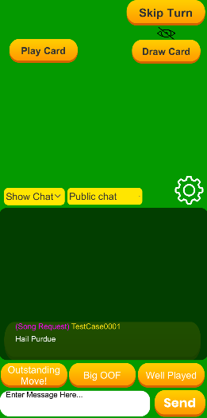

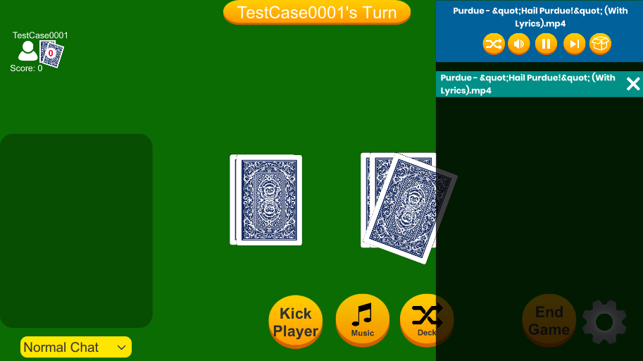

**Host side Client side**

**Test 2**

1. Start VirtuCardClient application
2. Click the button labeled “Sign In”
3. Enter “virtucards01@gmail.com” into the text input labeled “Enter email…”
4. Enter “Testing1” into the text input labeled “Enter password…”
5. Press the button labeled “Login”
6. A window should appear saying “Login Success”
7. Press the OK button that appears on that window
8. Start VirtuCardHost application
9. Repeat steps 2-7 but on the VirtuCardHost application
10. The checkbox “Allow Host to Join” should be checked on the host
11. Select the game “TestGame” from the dropdown
12. Press the Create Game button
13. In the VirtuCardClient application enter the 6-character room code found on the host’s screen into the field labeled “Enter Code…”
14. Press the Join Game button on the client
15. On the host side, press the Start Game button
16. On the client type “!play Hail Purdue” into the chat box
17. Press the button labeled “Send”
18. On the host, click the button labeled “Music”
19. Press the pause button on the top of the music panel

**Expected Result:** The song should pause its playback, and the pause button should turn into a play button

**Before Pressing pause**

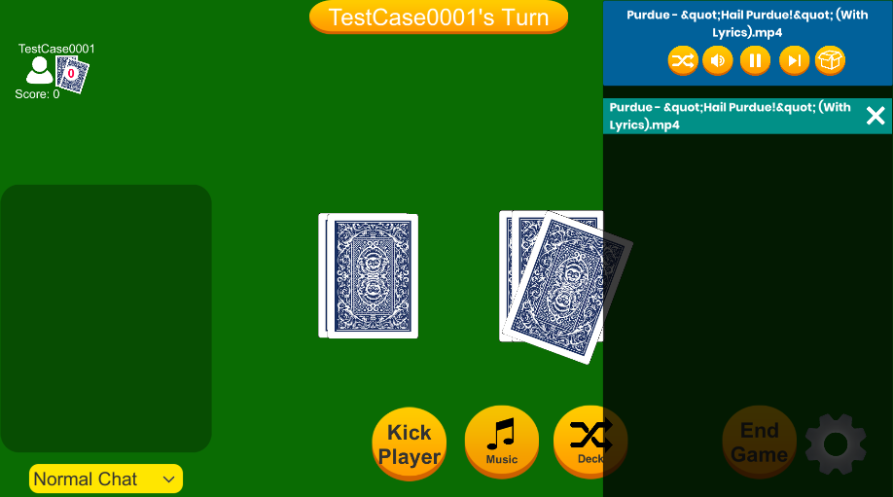

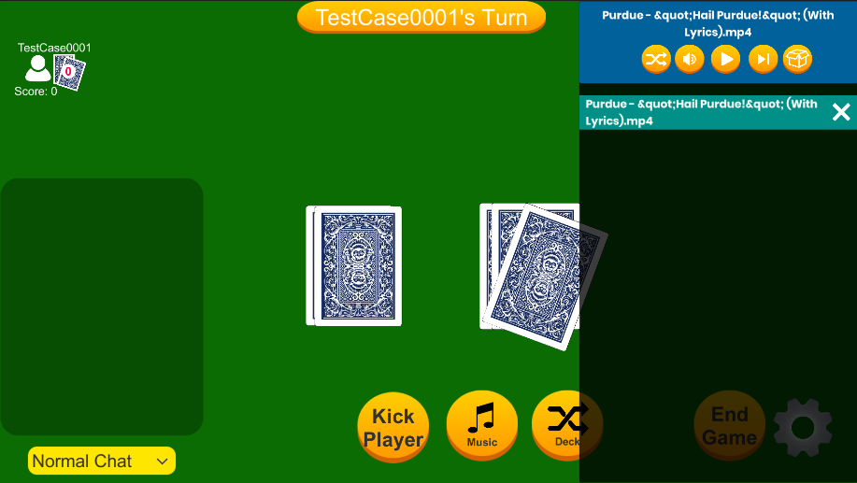**After Pressing Pause**

**Test 3**

1. Start VirtuCardClient application
2. Click the button labeled “Sign In”
3. Enter “virtucards01@gmail.com” into the text input labeled “Enter email…”
4. Enter “Testing1” into the text input labeled “Enter password…”
5. Press the button labeled “Login”
6. A window should appear saying “Login Success”
7. Press the OK button that appears on that window
8. Start VirtuCardHost application
9. Repeat steps 2-7 but on the VirtuCardHost application
10. The checkbox “Allow Host to Join” should be checked on the host
11. Select the game “TestGame” from the dropdown
12. Press the Create Game button
13. In the VirtuCardClient application enter the 6-character room code found on the host’s screen into the field labeled “Enter Code…”
14. Press the Join Game button on the client
15. On the host side, press the Start Game button
16. On the client type “!play Hail Purdue” into the chat box
17. Press the button labeled “Send”
18. On the client type “!play we are the champions” into the chat box
19. Press the button labeled “Send”
20. On the host, click the button labeled “Music”
21. Wait for the song “Hail Purdue” to finish playing

**Expected Result:** The song “Hail Purdue” should be removed from the queue, and the song “We are the Champions should start playing.

**Before “Hail Purdue” Finished**

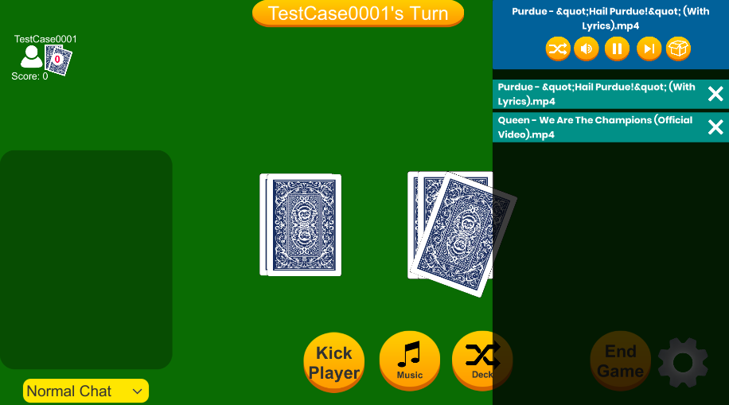

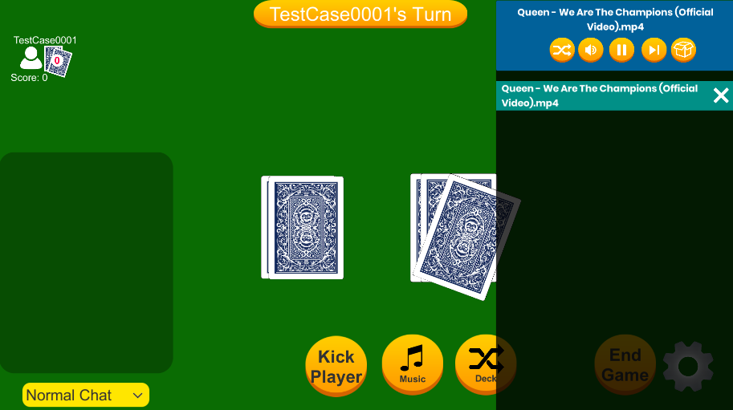**After “Hail Purdue” Finished**

**Test 4**

1. Start VirtuCardClient application
2. Click the button labeled “Sign In”
3. Enter “virtucards01@gmail.com” into the text input labeled “Enter email…”
4. Enter “Testing1” into the text input labeled “Enter password…”
5. Press the button labeled “Login”
6. A window should appear saying “Login Success”
7. Press the OK button that appears on that window
8. Start VirtuCardHost application
9. Repeat steps 2-7 but on the VirtuCardHost application
10. The checkbox “Allow Host to Join” should be checked on the host
11. Select the game “TestGame” from the dropdown
12. Press the Create Game button
13. In the VirtuCardClient application enter the 6-character room code found on the host’s screen into the field labeled “Enter Code…”
14. Press the Join Game button on the client
15. On the host side, press the Start Game button
16. On the client type “!play Hail Purdue” into the chat box
17. Press the button labeled “Send”
18. On the client type “!play we are the champions” into the chat box
19. Press the button labeled “Send”
20. On the host, click the button labeled “Music”
21. Press the Skip button on the music panel

**Expected Result:** The song “Hail Purdue” should be removed from the queue, and the song “We are the Champions should start playing.

**Before Skip Button Pressed**



**After Skip Button Pressed**